|  |
| --- |
| MIS : 112103143  Name : Sachin Sugadare  Div : 2 ( Batch : S3 ) |

Assignment 7

Create a script named hello_world and write a single line in it.



Now, call it with bash



Creating multiline bash script

Creating an empty file with current timestamp





Add execute permissions to the file

Debugging

Special Parameters



All Parameters

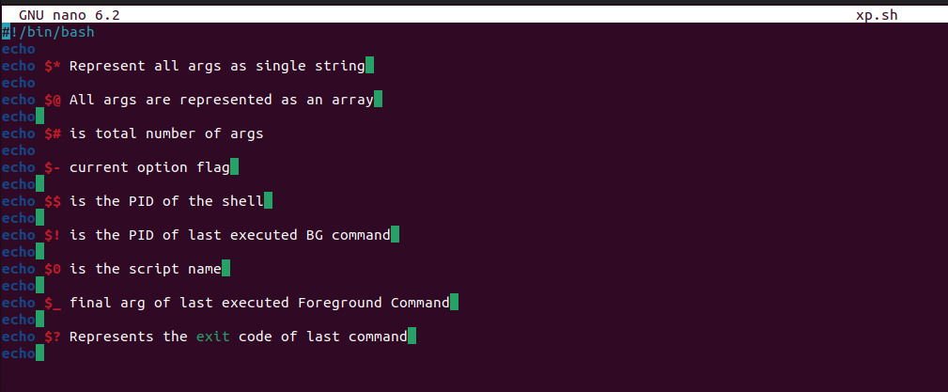

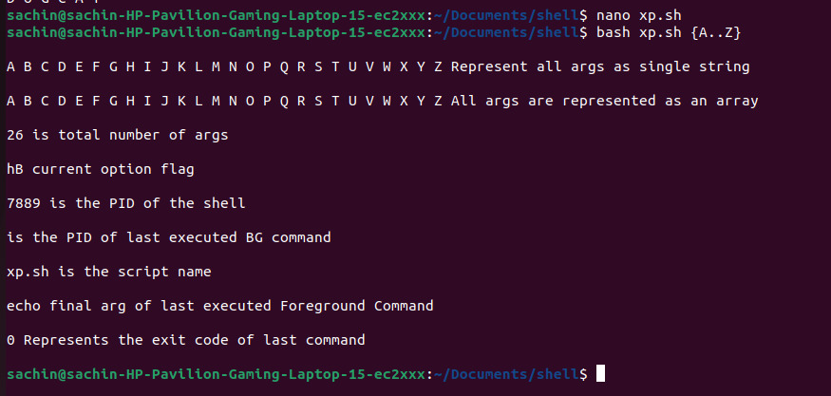

Shell Expansion

1. Brace Expansion

2. Parameter Expansion

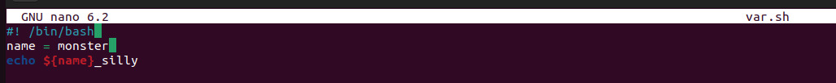

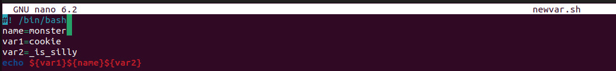

3. Arithmetic Expansion

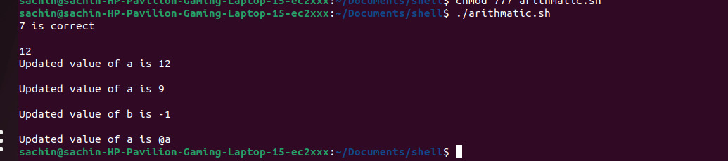

4. Command Expansion

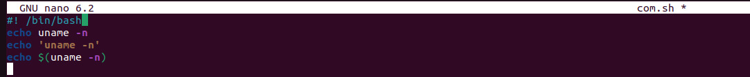

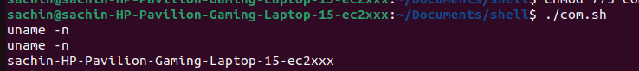

Variables

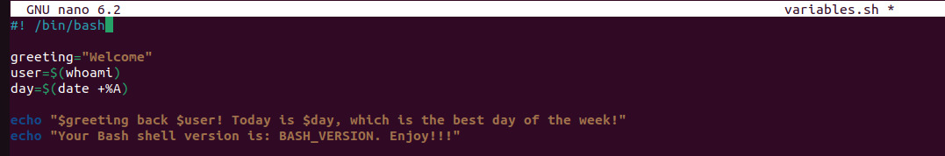

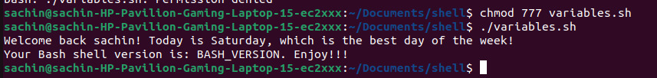

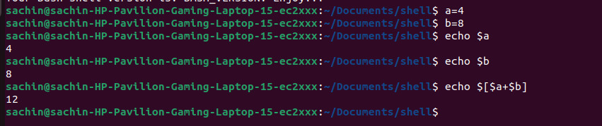

Environment

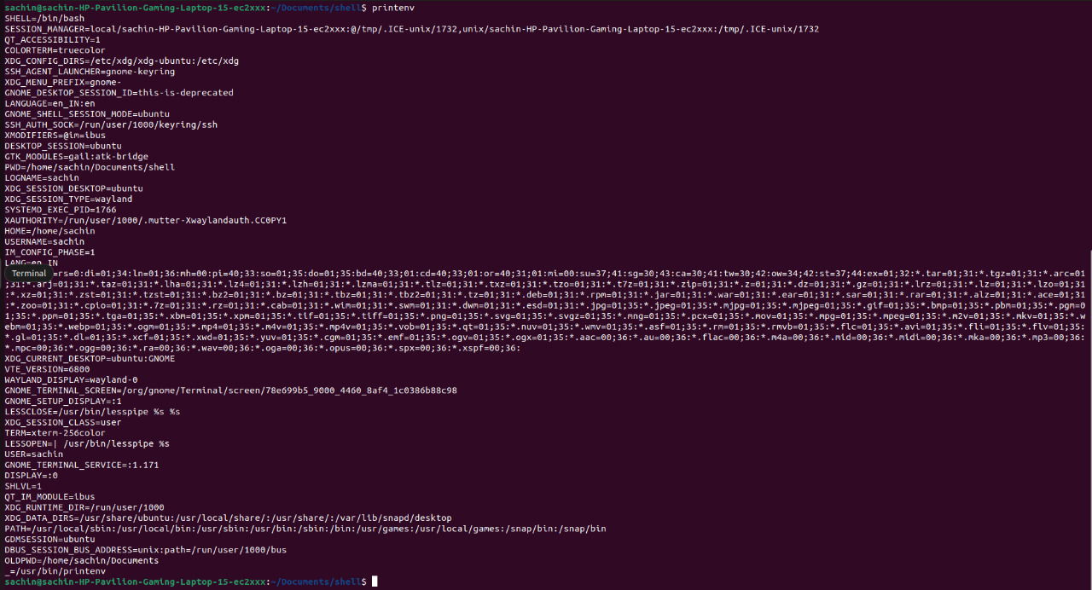

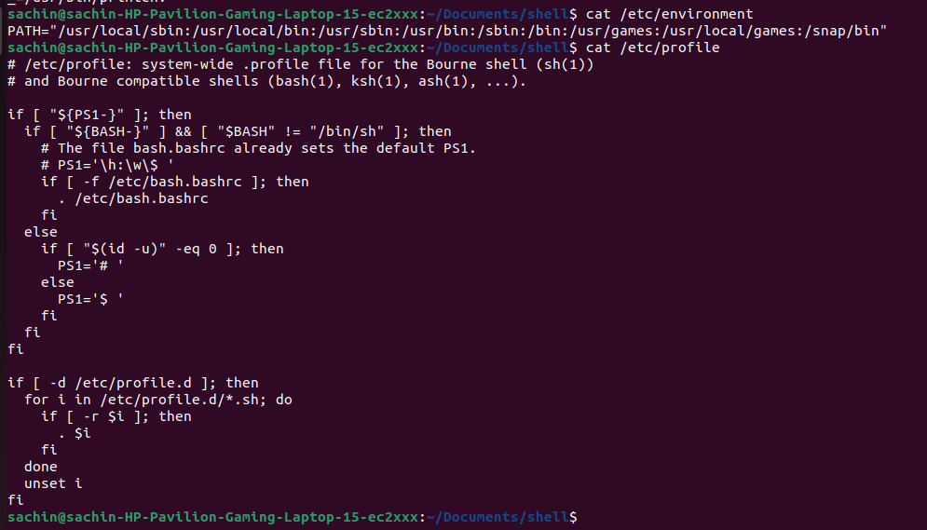

Input, Output and Error Redirection



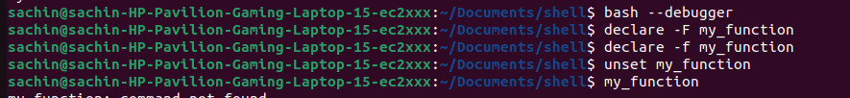

Numeric and String Comparison



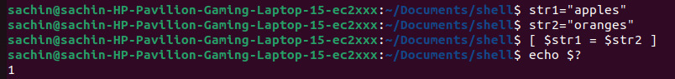

Conditional Statement



Arithmetic Operations

